./

Learning Report – Calculator Application

Course Code: <CODE>



|  |  |  |  |  |  |
| --- | --- | --- | --- | --- | --- |
| **Ver. Rel. No.** | **Release Date** | **Prepared. By** | **Reviewed By** | **Approved By** | **Remarks/Revision Details** |
|  |  |  |  |  |  |
|  |  |  |  |  |  |
|  |  |  |  |  |  |
|  |  |  |  |  |  |
|  |  |  |  |  |  |

**Document History**

# 

# Table of Contents

Requirements……………………………………………………………………………………………………………………………….5

Research…………………………………………………………………………………………………………………………………….5

Ageing………………………………………………………………………………………………………………………………………..5

Costing Gradation……………………………………………………………………………………………………………………….5

SWOT Analysis…………………………………………………………………………………………………………………………….6

High level requirements…………………………………………………………………………………………………………………….7

low level requirements………………………………………………………………………………………………………………………7

Test plan…………………………………………………………………………………………………………………………………………….7

Scenario based test cases…………………………………………………………………………………………………………….7

Requirement based test cases……………………………………………………………………………………………………..8

Agile methodology……………………………………………………………………………………………………………………………..9

User stories…………………………………………………………………………………………………………………………………..9

Design…………………………………………………………………………………………………………………………………………………10

Behavioural diagram…………………………………………………………………………………………………………………….10

Structural diagram…………………………………………………………………………………………………………………………12

Git hub badges…………………………………………………………………………………………………………………………………….15

**Table of figures**

Figure 1 10

Figure 2 10

Figure 3 11

Figure 4 12

Figure 5 12

Figure 6 13

Figure 7 16

Figure 8 16

**CALCULATOR APPLICATION**

**REQUIREMENTS**

**RESEARCH**

Calculators are small, portable electronic devices used to perform simple as well as complex calculations in a fraction of second. The idea of a calculator came from Abacus used long back in 2000 BC; after that there were various inventions and mechanical calculators came in use . Scientific calculators were made to solve the scientific calculations. But in the 21st century where people have started using laptops, tablets, smartphones etc. then why would they carry such calculators. So in this research paper I am introducing an android application known as the All in one calculator, where in all sorts of calculations from simple arithmetic calculations to long scientific calculations can be done in just a click on the smartphone screen. The users of this application will have a tool to do all sorts of calculations with ease.A software calculator is a calculator that has been implemented as a computer program rather than a physical hardware device which makes our work simpler. They are among the simple interactive tool inbuilt in our smartphones by default. Some of the operations they provide be like: i. provide operations of users to select one at a time ii. Can be used to perform any process that consists of sequence of steps each of these apply to one of these operations.

**AGEING**

**Past:** In early years, when computers were first introduced during 1940s and 1950s, the software that they ran was naturally used to perform calculation, but it was specially designed for substantial application that was not limited to simple calculation .eg Computers were used to do payroll operation. And then comes the VisiCalc , which is basically a spreadsheet that does simple operations.

**Present:** Simple and easy to use . Suitable and fast operation. Can be used offline. Possibility to use keyboard and mouse. Possibility to work with several numbers at once.

**Future:** The future of calculators apps are continuously growing constantly. It’s hard to predict what will come next. More likely, a few more operations would be added to the calculators apps which makes our complex operation simple and this would be the future of smartphones.

**COSTING GRADATION**

* Smartphone makers are pricing themselves out of market.
* Here are some comparisons between three brands latest model based on their features and price.

|  |  |  |  |
| --- | --- | --- | --- |
| Features | IPhone XS | Oppo A53 | Samsung galaxy s20 ultra 5G |
| camera | 12 MP+ 12MP | 13 MP+ 2 MP+ 2MP | 108 MP+48 MP+12 MP |
| Battery | 2658 MAH | 5000 MAH | 5000 MAH |
| Display | 14.73 cm | 16.51 cm | 17.53 cm |
| ram | 4 GB | 64 GB | 128 GB |
| price | RS 59,999 | RS 15,990 | RS 97,999 |

**SWOT Analysis**

**Strength:**

* + Newer and better products.
  + phones are available at affordable prices.
  + Hi-end Technology

**Weakness:**

* + - Internet speed on mobile
    - Highly competitive
    - Through R&D required
    - Low end products yield very less margin

**Oppurtunities:**

* + - Rising data usage
    - Growing rural numbers

**Threat:**

* + - Competition
    - Virus attack

**High level requirements:**

* + Performance
  + Scalability
  + Reliability
  + Availability
  + Serviceability
  + Maintainability

**Low level requirements:**

* + Authentication
  + Authorization levels

**TESTING**

**SCENARIO BASED TESTCASES**

|  |  |  |  |  |  |  |
| --- | --- | --- | --- | --- | --- | --- |
| ID | DESCRIPTION | PRE  CONDITION | EXPECTED  OUTPUT | EXPECTED INPUT | ACTUAL OUTPUT | PASS/FAIL |
| 1. | Verify that all the touch screen is working properly. | Screen is built | Users should be able to operate and interact with the screen | Users are expected to operate with touch screen. | As expected | PASS |
| 2. | Verify that the user can make a call by pressing numbers and hitting the  green(calling) button | The call attending option is in built which is green in color. | User must able to make calls and attend the calls by swiping up or right the green button. | Expected to give inputs by making calls or attending by swiping up. | As expected | PASS |
| 3. | Verify that the user can make a call by selecting a contact person from the phone directory | The contacts app is inbuilt. | User should be able to make and manage calls from their saved contact lists. | Selecting from their contacts. | As expected | PASS |
| 4. | Verify that the user can reject an incoming call | Ignoring the call option which is done by swiping left or down and would be in red color is present. | Users should also be able to reject the incoming calls with the help of the red button. | User expected to ignore the incoming call. | As Expected | PASS |

**REQUIREMENT BASED TESTCASES**

|  |  |  |  |  |  |  |
| --- | --- | --- | --- | --- | --- | --- |
| ID | DESCRIPTION | PRE-CONDITION | EXPECTED OUTPUT | EXPECTED INPUT | ACTUAL OUTPUT | PASS/FAIL |
| 1. | Verify whether the sim cards are placed in their respective places. | The sim card holder in smartphones are present. | Users should able to see their sim usage details appearing on screen when inserted. | Users expected to insert their sim cards to their mobile. | As expected | PASS |
| 2. | Verify whether the battery is placed. | Batteries are built. | Users should be able to see the battery percentage on the top of their screen. | Users are expected to charge their batteries when needed. | As expected | PASS |

**AGILE METHODOLOGY**

Agile methodology is an incremental and iterative mobile application development approach, where the complete development process cycle is divided into multiple sub modules, considering as mini projects. Every sub module is assigned to an individual team and subjected to complete development cycle, right form designing to development, testing and delivery.

**Benefits of using this approach:**

* + Faster development
  + Reduced risks
  + Better quality
  + Seamless project management
  + Lower development Cost

**User Stories:**

*‘As a smartphone user, we need verification like fingerprint or pin number or password in-order to unlock the smartphone. So, when user enters his/her password or pin, he/she is logged in their mobile phones’*

*‘As a smartphone user, securing smartphone is one of the growing concerns, especially when this data represents valuable or sensitive information’*

*‘As a user, we would expect memory of atleast 4GB RAM and 64 GB storage, 6 inches FHD plus display and a camera with sensor with larger pixels are more desirable because bigger the pixels are, more likely you are to get great picture quality from the camera’*

**DESIGN**

**BEHAVIOURAL DIAGRAM**

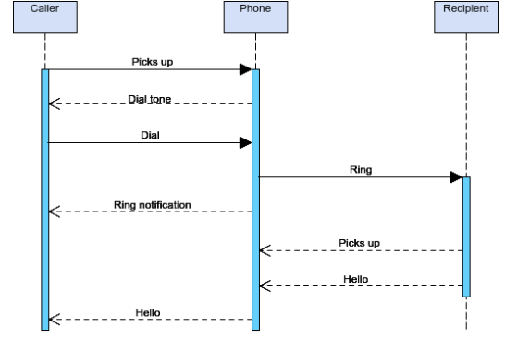

Figure

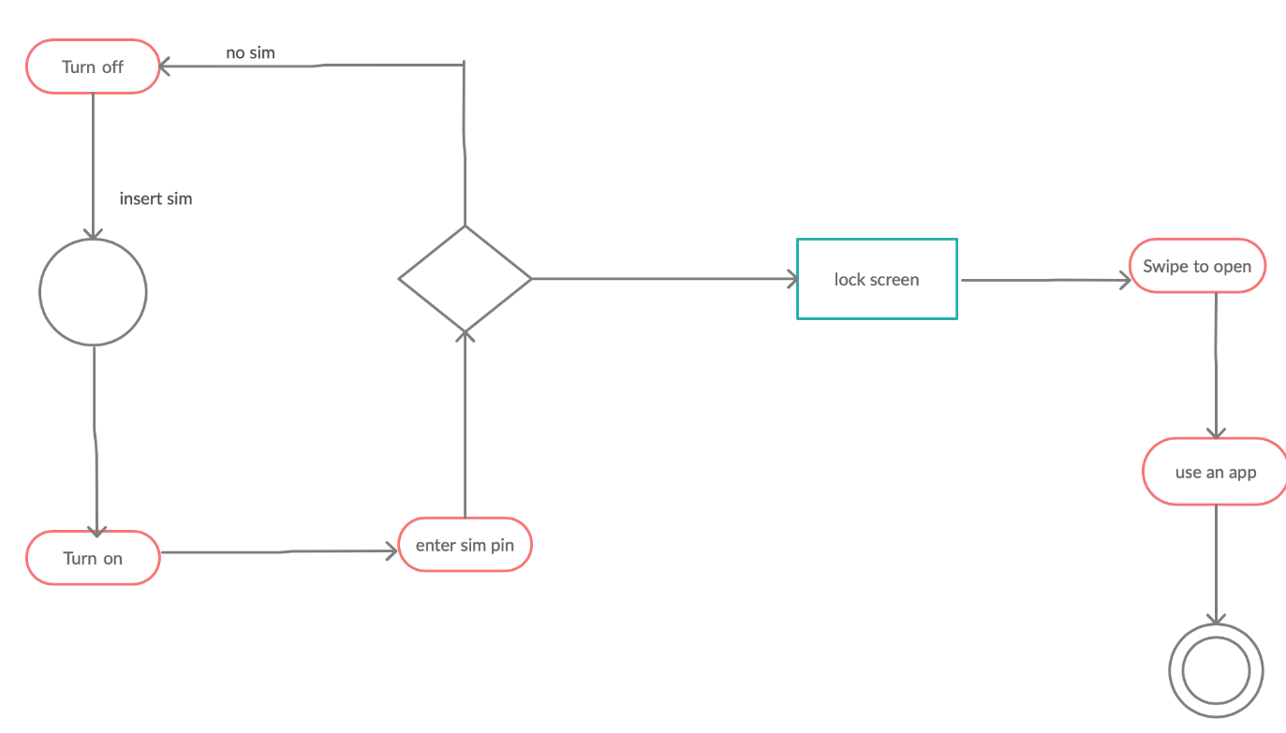

Figure

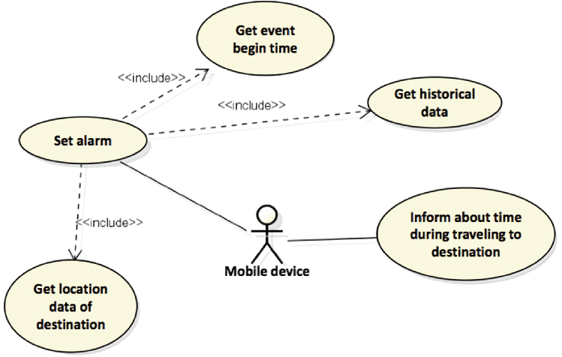

Figure

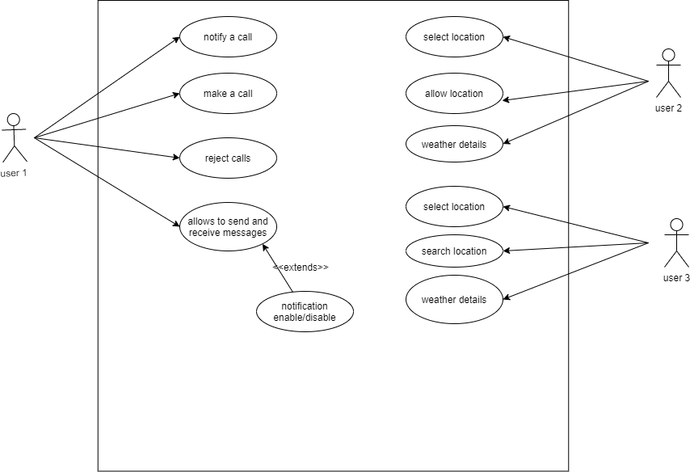

Figure

**STRUCTURAL DIAGRAM**

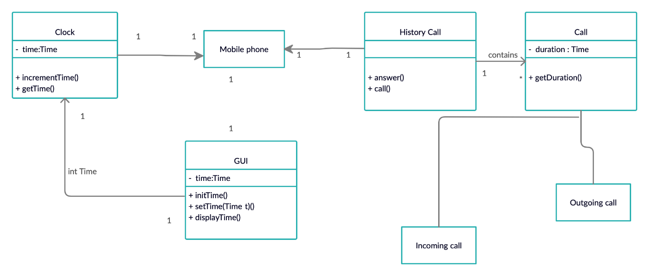

Figure

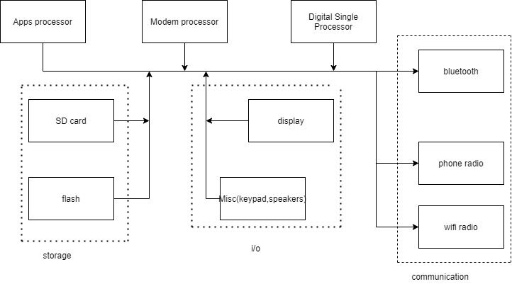

Figure

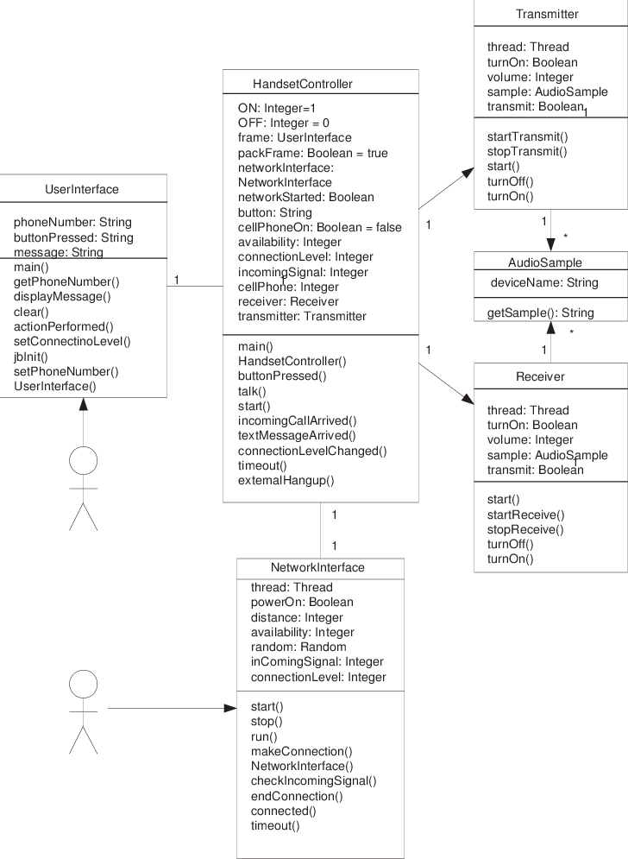

Figure

**GITHUB BAGDE**

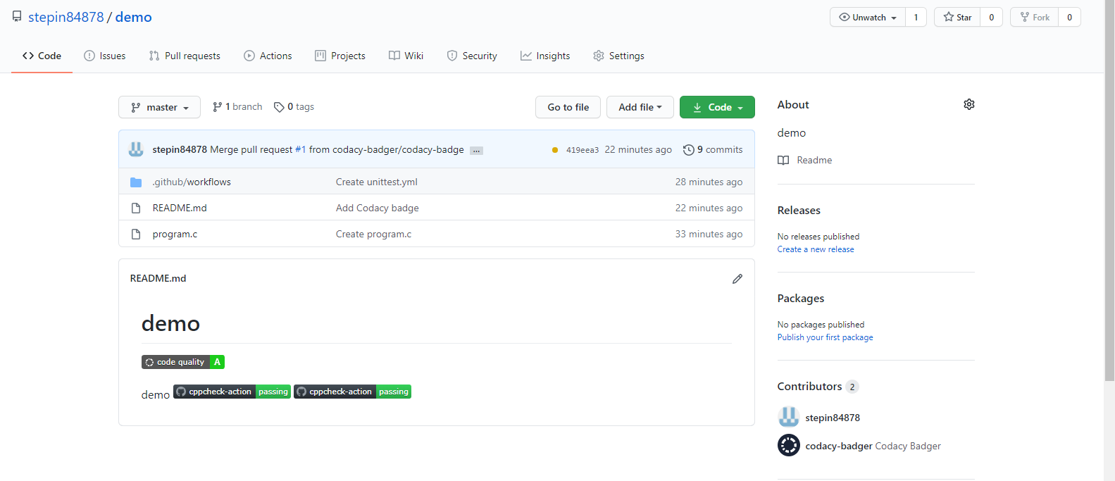

Figure

**SMART PHONE**

**REQUIREMENTS**

**RESEARCH**

Smartphones became our basic neccessity in our day to day life where we could not even think about how life would be without smartphones. A handy device which is helping people from look and corners of the world with information and much more.

**AGEING**

**Past:** The first smartphone which came into existence in 1994 wasn’t very compact and sleek but still features several elements that became staples to every smartphone that followed like email, fax, notes, calendar.

**Present:** There are many new features added to the current market smartphones. We could say, improvements in the storage capacity, speed, use of multiple applications at the same time, pixels, battery etc.

**Future:** The future of smartphones continues to grow constantly. It’s hard to predict what will come next. More likely, a flipflop with folding touchscreen would be the future of smartphones.

**COSTING GRADATION**

* Smartphone makers are pricing themselves out of market.
* Here are some comparisons between three brands latest model based on their features and price.

|  |  |  |  |
| --- | --- | --- | --- |
| Features | IPhone XS | Oppo A53 | Samsung galaxy s20 ultra 5G |
| camera | 12 MP+ 12MP | 13 MP+ 2 MP+ 2MP | 108 MP+48 MP+12 MP |
| Battery | 2658 MAH | 5000 MAH | 5000 MAH |
| Display | 14.73 cm | 16.51 cm | 17.53 cm |
| ram | 4 GB | 64 GB | 128 GB |
| price | RS 59,999 | RS 15,990 | RS 97,999 |

**SWOT Analysis**

**Strength:**

* + Newer and better products.
  + phones are available at affordable prices.
  + Hi-end Technology

**Weakness:**

* + - Internet speed on mobile
    - Highly competitive
    - Through R&D required
    - Low end products yield very less margin

**Oppurtunities:**

* + - Rising data usage
    - Growing rural numbers

**Threat:**

* + - Competition
    - Virus attack

**High level requirements:**

* + Performance
  + Scalability
  + Reliability
  + Availability
  + Serviceability
  + Maintainability

**Low level requirements:**

* + Authentication
  + Authorization levels

**TESTING**

**SCENARIO BASED TESTCASES**

|  |  |  |  |  |  |  |
| --- | --- | --- | --- | --- | --- | --- |
| ID | DESCRIPTION | PRE  CONDITION | EXPECTED  OUTPUT | EXPECTED INPUT | ACTUAL OUTPUT | PASS/FAIL |
| 1. | Verify that all the touch screen is working properly. | Screen is built | Users should be able to operate and interact with the screen | Users are expected to operate with touch screen. | As expected | PASS |
| 2. | Verify that the user can make a call by pressing numbers and hitting the  green(calling) button | The call attending option is in built which is green in color. | User must able to make calls and attend the calls by swiping up or right the green button. | Expected to give inputs by making calls or attending by swiping up. | As expected | PASS |
| 3. | Verify that the user can make a call by selecting a contact person from the phone directory | The contacts app is inbuilt. | User should be able to make and manage calls from their saved contact lists. | Selecting from their contacts. | As expected | PASS |
| 4. | Verify that the user can reject an incoming call | Ignoring the call option which is done by swiping left or down and would be in red color is present. | Users should also be able to reject the incoming calls with the help of the red button. | User expected to ignore the incoming call. | As Expected | PASS |

**REQUIREMENT BASED TESTCASES**

|  |  |  |  |  |  |  |
| --- | --- | --- | --- | --- | --- | --- |
| ID | DESCRIPTION | PRE-CONDITION | EXPECTED OUTPUT | EXPECTED INPUT | ACTUAL OUTPUT | PASS/FAIL |
| 1. | Verify whether the sim cards are placed in their respective places. | The sim card holder in smartphones are present. | Users should able to see their sim usage details appearing on screen when inserted. | Users expected to insert their sim cards to their mobile. | As expected | PASS |
| 2. | Verify whether the battery is placed. | Batteries are built. | Users should be able to see the battery percentage on the top of their screen. | Users are expected to charge their batteries when needed. | As expected | PASS |

**AGILE METHODOLOGY**

Agile methodology is an incremental and iterative mobile application development approach, where the complete development process cycle is divided into multiple sub modules, considering as mini projects. Every sub module is assigned to an individual team and subjected to complete development cycle, right form designing to development, testing and delivery.

**Benefits of using this approach:**

* + Faster development
  + Reduced risks
  + Better quality
  + Seamless project management
  + Lower development Cost

**User Stories:**

*‘As a smartphone user, we need verification like fingerprint or pin number or password in-order to unlock the smartphone. So, when user enters his/her password or pin, he/she is logged in their mobile phones’*

*‘As a smartphone user, securing smartphone is one of the growing concerns, especially when this data represents valuable or sensitive information’*

*‘As a user, we would expect memory of atleast 4GB RAM and 64 GB storage, 6 inches FHD plus display and a camera with sensor with larger pixels are more desirable because bigger the pixels are, more likely you are to get great picture quality from the camera’*

**DESIGN**

**BEHAVIOURAL DIAGRAM**



Figure 1



Figure 2



Figure 3



Figure 4

**STRUCTURAL DIAGRAM**



Figure 5



Figure 6

Figure 7

**GITHUB BAGDE**



Figure 8